Chapter 3

Financial Decision Making and the Law of One Price
3-1. Honda Motor Company is considering offering a $2000 rebate on its minivan, lowering the vehicle’s price from $30,000 to $28,000. The marketing group estimates that this rebate will increase sales over the next year from 40,000 to 55,000 vehicles. Suppose Honda’s profit margin with the rebate is $6000 per vehicle. If the change in sales is the only consequence of this decision, what are its costs and benefits? Is it a good idea?
The benefit of the rebate is that Honda will sell more vehicles and earn a profit on each additional vehicle sold:

Benefit = Profit of $6,000 per vehicle × 15,000 additional vehicles sold = $90 million.
The cost of the rebate is that Honda will make less on the vehicles it would have sold:

Cost = Loss of $2,000 per vehicle × 40,000 vehicles that would have sold without rebate = $80 million.
Thus, Benefit – Cost = $90 million – $80 million = $10 million, and offering the rebate looks attractive.
(Alternatively, we could view it in terms of total, rather than incremental, profits. The benefit as $6000/vehicle × 55,000 sold = $330 million, and the cost is $8,000/vehicle × 40,000 sold = $320 million.)
3-2. You are an international shrimp trader. A food producer in the Czech Republic offers to pay you 2 million Czech koruna today in exchange for a year’s supply of frozen shrimp. Your Thai supplier will provide you with the same supply for 3 million Thai baht today. If the current competitive market exchange rates are 25.50 koruna per dollar and 41.25 baht per dollar, what is the value of this deal?
Czech buyer’s offer = 2,000,000 CZK / (25.50 CZK/USD) = 78,431.37 USD.
Thai supplier’s offer = 3,000,000 THB / (41.25 THB/USD) = 72,727.27 USD.
The value of the deal is $78,431 – 72,727 = $5704 today.
3-3. Suppose the current market price of corn is $3.75 per bushel. Your firm has a technology that can convert 1 bushel of corn to 3 gallons of ethanol. If the cost of conversion is $1.60 per bushel, at what market price of ethanol does conversion become attractive?
The price in which ethanol becomes attractive is ($3.75 + $1.60 / bushel of corn) / (3 gallons of ethanol / bushel of corn) = $1.78 per gallon of ethanol.
3-4. Suppose your employer offers you a choice between a $5000 bonus and 100 shares of the company stock. Whichever one you choose will be awarded today. The stock is currently trading for $63 per share.
a. Suppose that if you receive the stock bonus, you are free to trade it. Which form of the bonus should you choose? What is its value?
b. Suppose that if you receive the stock bonus, you are required to hold it for at least one year. What can you say about the value of the stock bonus now? What will your decision depend on?
a. Stock bonus = 100 × $63 = $6,300
Cash bonus = $5,000
Since you can sell (or buy) the stock for $6,300 in cash today, its value is $6,300 which is better than the cash bonus.
b. Because you could buy the stock today for $6,300 if you wanted to, the value of the stock bonus cannot be more than $6,300. But if you are not allowed to sell the company’s stock for the next year, its value to you could be less than $6,300. Its value will depend on what you expect the stock to be worth in one year, as well as how you feel about the risk involved. You might decide that it is better to take the $5,000 in cash than wait for the uncertain value of the stock in one year.
3-5. You have decided to take your daughter skiing in Utah. The best price you have been able to find for a roundtrip air ticket is $359. You notice that you have 20,000 frequent flier miles that are about to expire, but you need 25,000 miles to get her a free ticket. The airline offers to sell you 5000 additional miles for $0.03 per mile.
a. Suppose that if you don’t use the miles for your daughter’s ticket they will become worthless. What should you do?
b. What additional information would your decision depend on if the miles were not expiring? Why?
a. The price of the ticket if you purchase it is $t. The price if you purchase the miles is $p x 5000. So you should purchase the miles.
b. In part a, the existing miles are worthless if you don’t use them. They are not worthless now, so you must add in the cost of using them. Because there is no competitive market price for these miles (you can purchase at 3¢ but not sell for that price) the decision will depend on how much you value the existing miles (which will depend on your likelihood of using them in the future).
3-6. Suppose the risk-free interest rate is 4%.

a. Having $200 today is equivalent to having what amount in one year?
b. Having $200 in one year is equivalent to having what amount today?
c. Which would you prefer, $200 today or $200 in one year? Does your answer depend on when you need the money? Why or why not?
a. Having $200 today is equivalent to having 200 × 1.04 = $208 in one year.
b. Having $200 in one year is equivalent to having 200 / 1.04 = $192.31 today.
c. Because money today is worth more than money in the future, $200 today is preferred to $200 in one year. This answer is correct even if you don’t need the money today, because by investing the $200 you receive today at the current interest rate, you will have more than $200 in one year.
3-7. You have an investment opportunity in Japan. It requires an investment of $1 million today and will produce a cash flow of ¥ 114 million in one year with no risk. Suppose the risk-free interest rate in the United States is 4%, the risk-free interest rate in Japan is 2%, and the current competitive exchange rate is ¥ 110 per $1. What is the NPV of this investment? Is it a good opportunity?
Cost = $1 million today
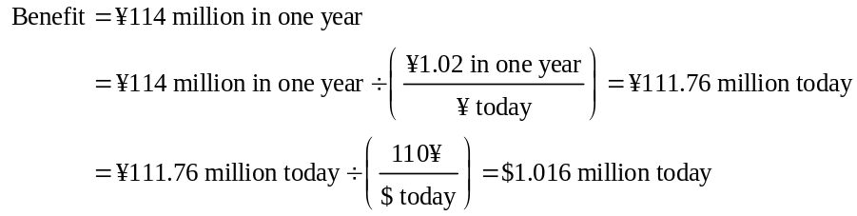
The NPV is positive, so it is a good investment opportunity.
3-8. Your firm has a risk-free investment opportunity where it can invest $160,000 today and receive $170,000 in one year. For what level of interest rates is this project attractive?
160,000 × (1 + r) = 170,000 implies r = 170,000/160,000 – 1 = 6.25%
3-9. You run a construction firm. You have just won a contract to construct a government office building. Constructing it will take one year and require an investment of $10 million today and $5 million in one year. The government will pay you $20 million upon the building’s completion. Suppose the cash flows and their times of payment are certain, and the risk-free interest rate is 10%.
a. What is the NPV of this opportunity?
b. How can your firm turn this NPV into cash today?
a. 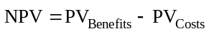
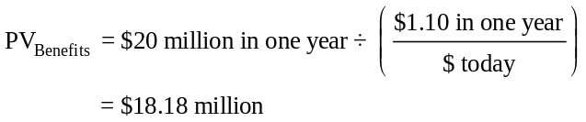
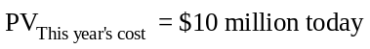
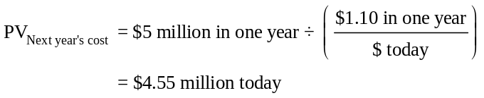
b. The firm can borrow $18.18 million today, and pay it back with 10% interest using the $20 million it will receive from the government (18.18 × 1.10 = 20). The firm can use $10 million of the 18.18 million to cover its costs today and save $4.55 million in the bank to earn 10% interest to cover its cost of 4.55 × 1.10 = $5 million next year.
This leaves 18.18 – 10 – 4.55 = $3.63 million in cash for the firm today.
3-10. Your firm has identified three potential investment projects. The projects and their cash flows are shown here:
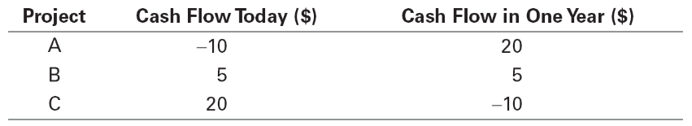

Suppose all cash flows are certain and the risk-free interest rate is 10%.
a. What is the NPV of each project?
b. If the firm can choose only one of these projects, which should it choose?
c. If the firm can choose any two of these projects, which should it choose?
a. 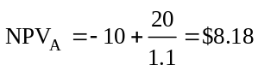
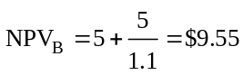
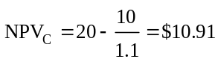
b. If only one of the projects can be chosen, project C is the best choice because it has the highest NPV.
c. If two of the projects can be chosen, projects B and C are the best choice because they offer a higher total NPV than any other combinations.
3-11. Your computer manufacturing firm must purchase 10,000 keyboards from a supplier. One supplier demands a payment of $100,000 today plus $10 per keyboard payable in one year. Another supplier will charge $21 per keyboard, also payable in one year. The risk-free interest rate is 6%.
a. What is the difference in their offers in terms of dollars today? Which offer should your firm take?
b. Suppose your firm does not want to spend cash today. How can it take the first offer and not spend $100,000 of its own cash today?
a. 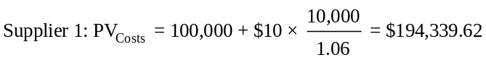
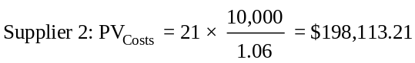
Costs are lower under the first supplier’s offer, so it is better choice.
b. The firm can borrow $100,000 at 6% from a bank for one year to make the initial payment to the first supplier. One year later, the firm will pay back the bank $106,000 (100,000 × 1.06) and the first supplier $100,000 (10 × 10,000), for a total of $206,000. This amount is less than the $210,000 (21 × 10,000) the second supplier asked for.
3-12. Suppose Bank One offers a risk-free interest rate of 5.5% on both savings and loans, and Bank Enn offers a risk-free interest rate of 6% on both savings and loans.
a. What arbitrage opportunity is available?
b. Which bank would experience a surge in the demand for loans? Which bank would receive a surge in deposits?
c. What would you expect to happen to the interest rates the two banks are offering?
a. Take a loan from Bank One at 5.5% and save the money in Bank Enn at 6%.
b. Bank One would experience a surge in the demand for loans, while Bank Enn would receive a surge in deposits.
c. Bank One would increase the interest rate, and/or Bank Enn would decrease its rate.
3-13. Throughout the 1990s, interest rates in Japan were lower than interest rates in the United States. As a result, many Japanese investors were tempted to borrow in Japan and invest the proceeds in the United States. Explain why this strategy does not represent an arbitrage opportunity.
There is exchange rate risk. Engaging in such transactions may incur a loss if the value of the dollar falls relative to the yen. Because a profit is not guaranteed, this strategy is not an arbitrage opportunity.
3-14. An American Depositary Receipt (ADR) is security issued by a U.S. bank and traded on a U.S. stock exchange that represents a specific number of shares of a foreign stock. For example, Nokia Corporation trades as an ADR with symbol NOK on the NYSE. Each ADR represents one share of Nokia Corporation stock, which trades with symbol NOK1V on the Helsinki stock exchange. If the U.S. ADR for Nokia is trading for $17.96 per share, and Nokia stock is trading on the Helsinki exchange for 14.78 € per share, use the Law of One Price to determine the current $/€ exchange rate.
We can trade one share of Nokia stock for $17.96 per share in the U.S. and €14.78 per share in Helsinki. By the Law of One Price, these two competitive prices must be the same at the current exchange rate. Therefore, the exchange rate must be:
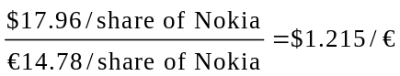 today.
3-15. The promised cash flows of three securities are listed here. If the cash flows are risk-free, and the risk-free interest rate is 5%, determine the no-arbitrage price of each security before the first cash flow is paid.
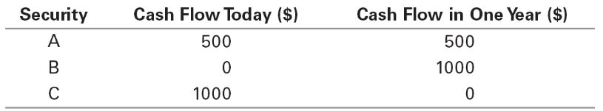
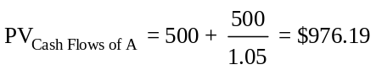
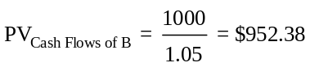
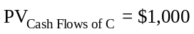
While the total cash flows paid by each security are the same ($1000), securities A and B are worth less than $1000 because some or all of the money is received in the future.
3-16. An Exchange-Traded Fund (ETF) is a security that represents a portfolio of individual stocks. Consider an ETF for which each share represents a portfolio of two shares of Hewlett-Packard (HPQ), one share of Sears (SHLD), and three shares of General Electric (GE). Suppose the current stock prices of each individual stock are as shown here:
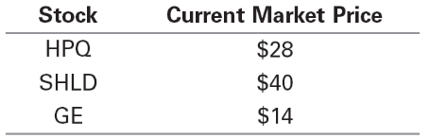
a. What is the price per share of the ETF in a normal market?
b. If the ETF currently trades for $120, what arbitrage opportunity is available? What trades would you make?
c. If the ETF currently trades for $150, what arbitrage opportunity is available? What trades would you make?
a. We can value the portfolio by summing the value of the securities in it:
Price per share of ETF = 2 × $28 + 1 × $40 + 3 × $14 = $138
b. If the ETF currently trades for $120, an arbitrage opportunity is available. To take advantage of it, one should buy the ETF for $120, sell two shares of HPQ, sell one share of SHLD, and sell three shares of GE. Total profit for such transaction is $18.
c. If the ETF trades for $150, an arbitrage opportunity is also available. It can be realized by buying two shares of HPQ, one share of SHLD, and three shares of GE, and selling one share of the ETF for $150. Total profit would be $12.
3-17. Consider two securities that pay risk-free cash flows over the next two years and that have the current market prices shown here:
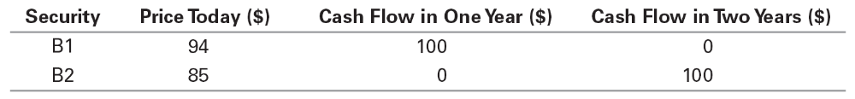
a. What is the no-arbitrage price of a security that pays cash flows of $100 in one year and $100 in two years?
b. What is the no-arbitrage price of a security that pays cash flows of $100 in one year and $500 in two years?
c. Suppose a security with cash flows of $50 in one year and $100 in two years is trading for a price of $130. What arbitrage opportunity is available?
a. This security has the same cash flows as a portfolio of one share of B1 and one share of B2. Therefore, its no-arbitrage price is 94 + 85 = $179.
b. This security has the same cash flows as a portfolio of one share of B1 and five shares of B2. Therefore, its no-arbitrage price is 94 + 5 × 85 = $519
c. There is an arbitrage opportunity because the no-arbitrage price should be $132 (94 / 2 + 85). One should buy two shares of the security at $130/share and sell one share of B1 and two shares of B2. Total profit would be $4 (94 + 85 × 2 – 130 × 2).
3-18. Suppose a security with a risk-free cash flow of $150 in one year trades for $140 today. If there are no arbitrage opportunities, what is the current risk-free interest rate?
The PV of the security’s cash flow is ($150 in one year)/(1 + r), where r is the one-year risk-free interest rate. If there are no arbitrage opportunities, this PV equals the security’s price of $140 today.
Therefore,
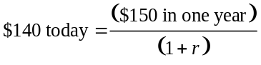
Rearranging:
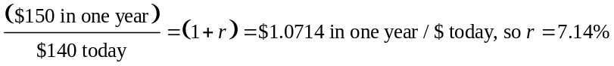
3-19. Xia Corporation is a company whose sole assets are $100,000 in cash and three projects that it will undertake. The projects are risk free and have the following cash flows:
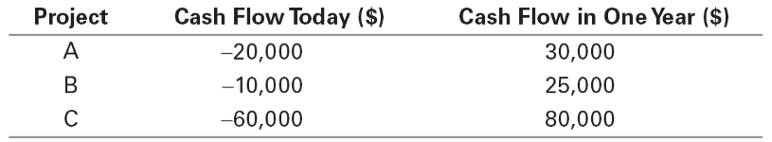
Xia plans to invest any unused cash today at the risk-free interest rate of 10%. In one year, all cash will be paid to investors and the company will be shut down.
a. What is the NPV of each project? Which projects should Xia undertake and how much cash should it retain?
b. What is the total value of Xia’s assets (projects and cash) today?
c. What cash flows will the investors in Xia receive? Based on these cash flows, what is the value of Xia today?
d. Suppose Xia pays any unused cash to investors today, rather than investing it. What are the cash flows to the investors in this case? What is the value of Xia now?
e. Explain the relationship in your answers to parts (b), (c), and (d).
a. 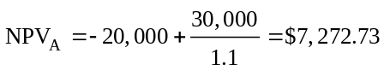
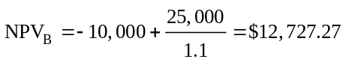
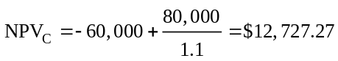
All projects have positive NPV, and Xia has enough cash, so Xia should take all of them.
b. Total value today = Cash + NPV(projects) = 100,000 + 7,272.73 + 12,727.27 + 12,727,27 = $132,727.27
c. After taking the projects, Xia will have 100,000 – 20,000 – 30,000 – 60,000 = $10,000 in cash left to invest at 10%. Thus, Xia’s cash flows in one year = 30,000 + 25,000 + 80,000 + 10,000 × 1.1 = $146,000.
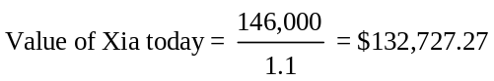
The same as calculated in b.
d. Unused cash = 100,000 – 20,000 – 30,000 – 60,000 = $10,000
Cash flows today = $10,000
Cash flows in one year = 30,000 + 25,000 + 80,000 = $135,000
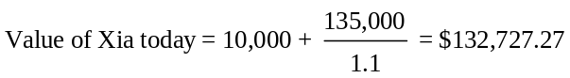
e. Results from b, c, and d are the same because all methods value Xia’s assets today. Whether Xia pays out cash now or invests it at the risk-free rate, investors get the same value today. The point is that a firm cannot increase its value by doing what investors can do by themselves (and is the essence of the separation principle).
3-A.1. The table here shows the no-arbitrage prices of securities A and B that we calculated.
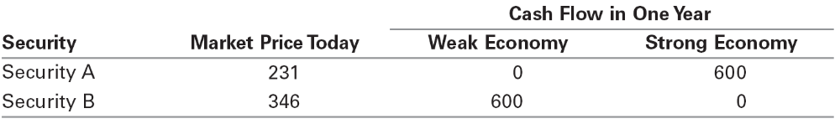
a. What are the payoffs of a portfolio of one share of security A and one share of security B?
b. What is the market price of this portfolio? What expected return will you earn from holding this portfolio?
a. pays 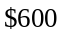 in both cases (i.e., it its risk free).
b. Market price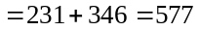. Expected return is 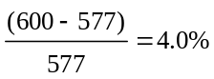
3.98% is the risk-free interest rate.
3-A.2. Suppose security C has a payoff of $600 when the economy is weak and $1800 when the economy is strong. The risk-free interest rate is 4%.
a. Security C has the same payoffs as which portfolio of the securities A and B in problem A-1?
b. What is the no-arbitrage price of security C?
c. What is the expected return of security C if both states are equally likely? What is its risk premium?
d. What is the difference between the return of security C when the economy is strong and when it is weak?
e. If security C had a risk premium of 10%, what arbitrage opportunity would be available?
a. 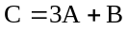
b. Price of 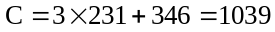
c. Expected payoff is 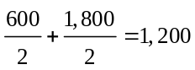; Expected return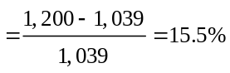
Risk premium 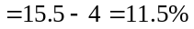
d. Return when strong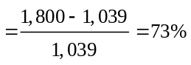; return when weak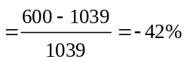
Difference 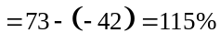
e. Price of C given 10% risk premium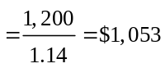
Buy 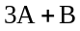 for 1039, sell C for 1053, and earn a profit of 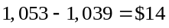.
3-A.3. You work for Innovation Partners and are considering creating a new security. This security would pay out $1000 in one year if the last digit in the closing value of the Dow Jones Industrial index in one year is an even number and zero if it is odd. The one-year risk-free interest rate is 5%. Assume that all investors are averse to risk.
a. What can you say about the price of this security if it were traded today?
b. Say the security paid out $1000 if the last digit of the Dow is odd and zero otherwise. Would your answer to part (a) change?
c. Assume both securities (the one that paid out on even digits and the one that paid out on odd digits) trade in the market today. Would that affect your answers?
a. Whether the last digit in the Dow is odd or even has no correlation with the Dow index itself or anything else in the economy. Hence the payout of this security does not vary with anything else in the economy, so it will not have a risk premium. So the price of the security will be 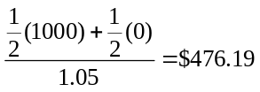.
b. No.
c. The answers would remain the same; however, in this case if the actual prices departed from $476.19, an arbitrage opportunity would result because by purchasing both securities you can create a riskless investment. The investment will only have a 5% return if the price of the basket of both securities is $476.19 × 2 = $952.38.
3-A.4. Suppose a risky security pays an expected cash flow of $80 in one year. The risk-free rate is 4%, and the expected return on the market index is 10%.
a. If the returns of this security are high when the economy is strong and low when the economy is weak, but the returns vary by only half as much as the market index, what risk premium is appropriate for this security?
b. What is the security’s market price?
a. Half as variable half the risk premium of market risk premium is 3%
b. Market price 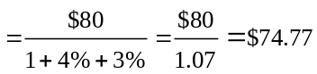
3-A.5. Suppose Hewlett-Packard (HPQ) stock is currently trading on the NYSE with a bid price of $28.00 and an ask price of $28.10. At the same time, a NASDAQ dealer posts a bid price for HPQ of $27.85 and an ask price of $27.95.
a. Is there an arbitrage opportunity in this case? If so, how would you exploit it?
b. Suppose the NASDAQ dealer revises his quotes to a bid price of $27.95 and an ask price of $28.05. Is there an arbitrage opportunity now? If so, how would you exploit it?
c. What must be true of the highest bid price and the lowest ask price for no arbitrage opportunity to exist?
a. There is an arbitrage opportunity. One would buy from the NASDAQ dealer at $27.95 and sell to NYSE dealer at $28.00, making profit of $0.05 per share.
b. There is no arbitrage opportunity.
c. To eliminate any arbitrage opportunity, the highest bid price should be lower then the lowest ask price.
3-A.6. Consider a portfolio of two securities: one share of Johnson and Johnson (JNJ) stock and a bond that pays $100 in one year. Suppose this portfolio is currently trading with a bid price of $141.65 and an ask price of $142.25, and the bond is trading with a bid price of $91.75 and an ask price of $91.95. In this case, what is the no-arbitrage price range for JNJ stock?
According to the Law of One Price, the price that portfolio of securities is trading at is equal to the sum of the price of securities within the portfolio. If the portfolio, composed of a bond and JNJ stock is currently trading with a bid price of $141.65 and an ask price of $142.25, and the bond is trading at a bid price of $91.75 and an ask price of $91.95, then the no-arbitrage price of the stock should be between $(141.65 – 91.95) and $(142.25 – 91.75) or between $49.70 and $50.50.
At any price below $49.90 or above $50.30 an arbitrage opportunity would exist. For example, if the stock were currently trading at $49, an investor could purchase the stock and the bond for $49 + $91.95 = $140.95 and then immediately sell the portfolio for $141.65 and have an arbitrage of $141.65 – 140.95 = $0.70. If the price of the stock was $50.60, then an investor could purchase the portfolio for $142.25 and sell the bond and stock individually for $91.75 and $50.60 respectively. The investor would gain an arbitrage of $91.75 + $50.60 – $142.25 = $0.10.

